**GURU NANAK KHAKLSA COLLEGE OF ARTS,**

**SCIENCE & COMMERCE (MATUNGA)**

**PROJECT REPORT**

**ON**

***SUPERMARKET MANAGEMENT SYSTEM***

SUBMITTED IN PARTIAL FULFILLMENT OF REUIREMENTS FOR THE DEGREE OF

***BACHELOR OF SCIENCE (COMPUTER SCIENCE)***

FOR THE ACADEMIC YEAR 2018-19

UNIVERSITY OF MUMBAI

SUBMITTED BY

***ADITYA VINAYAK NARKAR***

***(441)***

UNDER THE GUIDANCE OF

***PROF. RANDEEP SINGH GHAI***

***SUPERMARKET MANAGEMENT SYSTEM***

**Name:- Aditya Vinayak Narkar**

**Roll No:- 441**

**Std:-TYCS**



**ABSTRACT**

**(SYNOPSIS)**

**Background:**

You might have visited Grocery shop in your area. After shopping there’s always a long queue for bill payment. That typical old grocery shops use that traditional way to make bill. They manually write the order and calculate the total by adding manually, or by using calculator. It takes too much time. But the main problem is while making bill sometime due human error, total amount of bill gets wrong. If you have done shopping of 200 Rs. But in bill it shows 230rs. You know its show much hectic to find your desired product, you have to search it for long time.

Some of the shops are so congested that only 2-3 people can stand in that store. Most hating thing in shopping is that there confusing layout of the store. Some shops give very less or no discount even if you are regular member.

So to solve this kind of problem I have tried to make an application using .Net to make your shopping quiet easy. Rather than finding individually, go towards the counter and order the employee of your grocery. He will enter your wish list in software and deliver to you in few minutes. While you are giving order automatically your bill generate in background and it will give u exact bill.

Every thing is done on machine so there is not any problem of congested layout or anything.

**Objectives:**

This project is a software application which is designed in C# for managing sales, purchases, stock details which are going out and coming in to supermarket. Details are maintained in centralized database.

The main objective of our project is to make efficient transaction management system which is user friendly and at the same time powerful.

Making our system very reliable, very easier, very fast, and more informative than other websites.

This system facilitates the admin person to know items that are available the number of items that we have. Also system will facilitate customers to make order of items they need and paying the money using payment cards or cash.

A computerized supermarket management system makes everything from inputting information to taking inventory easier. By doing this work manually or by hand it will take hours and hours but by using the computerized way or our application they can do it in few minutes

**ACKNOWLEDGEMENTS**

I express my deep sense of gratitude to my respected and learned guides, Prof. Randeep Singh Ghai and Prof. Omprakash Prajapati for their valuable help and guidance, I am thankful to them for the encouragement they have given me in completing the project.

I am also grateful to respected HOD Prof. Jasmeet Kaur Ghai (CS) for permitting me to utilize all the necessary facilities of the Guru Nanak Khalsa College (Mumbai).

I am also grateful to all the other faculty & staff member of my department for their kind co-operation and help.

Lastly, I would like to express my deep apperception towards classmates and indebt to my parents for providing me the moral support and encouragement in each and every situation.

Aditya Vinayak Narkar

TYCS (441)

**TABLE OF CONTENTS**

|  |  |  |
| --- | --- | --- |
| **Sr. No.** | **Content** | **Page No.** |
| **1** | **Title** | **1** |
| **2** | **Synopsis** | **2** |
| **3** | **Acknowledgements** | **4** |
| **4** | **Introduction** | **8** |
| **5** | **Requirement Specification** | **11** |
| **6** | **System Design** | **13** |
| **7** | **System Implementation** | **23ss** |
| **8** | **Results** |  |
| **9** | **Conclusion and Future Scope** |  |
| **10** | **References** |  |
| **11** | **Plagiarism Report** |  |

**INTRODUCTION**

In today’s fast paced society, it’s very hard to be competitive without using cutting-edge technology available in market.

After years of business, the data has grown much. It is becoming a challenge for person to manage that data in an effective way. To be more productive in order processing, he needs a solution which can facilitate their current processes with use of technology and software

* Save time and energy: This system facilitates the admin person to know items that are available the number of items that we have. Also system will facilitate customers to make order of items they need and paying the money using payment cards or cash.
* It can also provide Quality of service to our customers by asking feedback from them
* Speed and Efficiency: A computerized supermarket management system makes everything from inputting information to taking inventory easier. By doing this work manually or by hand it will take hours and hours but by using the computerised way or our application they can do it in few minutes
* Document Generation: Once the computerized supermarket management system is in place, managers and workers can use it to automatically generate all kinds of documents, from purchase orders and checks to invoices and account statements. Rather than admin, managers can also use our application to automatically order products when they run low.
* Entire system will be automated. Managers can analyze sales on daily and monthly bases

In this project we are having three characters,

* **Administrator –**
* Admin person can add, edit and delete items
* Admin person creates users of the system giving some authority but not all.
* Admin person controls daily sells and feedbacks from customers.
* View the history of the customers who purchased the items.
* The main role of the administrator is to safeguard the database and can add/delete the products from the database.
* **Staff** – Sales person has a power given by the admin person, he will do the authority given. He cannot change anything from the system.
* Manage daily transactions and put into the computer.
* Sale items and put data into the system.
* Register new customers.
* **Customer** – The Regular members of the supermarket as well as the new registrars to the system may be able to use some area of the system, only for the purpose of viewing.

**REQUIREMENT SPECIFICATIONS**

In this project we need following things,

**Hardware:**

* Processor: Intel(R) Core(TM) i5-5200 CPU @2.20GHz
* Ram: 8.00 GB
* Hard disk: 20 GB

**Software:**

* Operating system: Windows 10
* Front end: JSP, JDBC, Java Script, Ajax
* Back end: SQL Server
* Tool: C# language (.Net Framework)

**SYSTEM DESIGN**

**Class Diagram**

A class diagram is an illustration of the relationships and source code dependencies among classes in the Unified Modeling Language (UML). In this context, a class defines the methods and variables in an object, which is a specific entity in a program or the unit of code representing that entity. Class diagrams are useful in all forms of object-oriented programming (OOP).

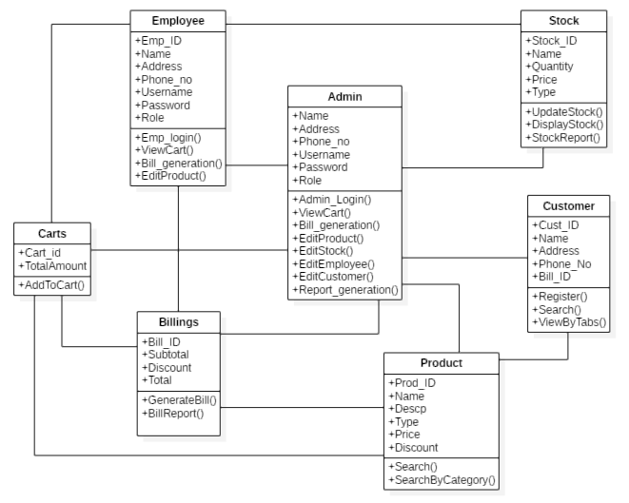

**E –R Diagram**

An entity–relationship model describes interrelated things of interest in a specific domain of knowledge. A basic ER model is composed of entity types and specifies relationships that can exist between instances of those entity types

**Entities with Corresponding Attributes:**

* **Billing –**

Bill_ID.

Sub Total.

Discount.

Total.

* **Cart –**

Cart_ID.

Total.

* **Customer –**

Cust_ID.

Name.

Address.

Phone No.

* **Employee –**

Emp_ID.

Name.

Address.

Username.

Password.

Role.

* **Product –**

Product_ID.

Name.

Description.

Price.

Type.

Discount.

* **Stock –**

Stock_ID.

Name.

Quantity.

Price.

Type.

* **Supplier –**

Supplier_ID.

Name.

Address.

Company name.

Price.

Quantity.

* **Administrator –**

Name.

Username.

Password.

Role.

Report Generation.

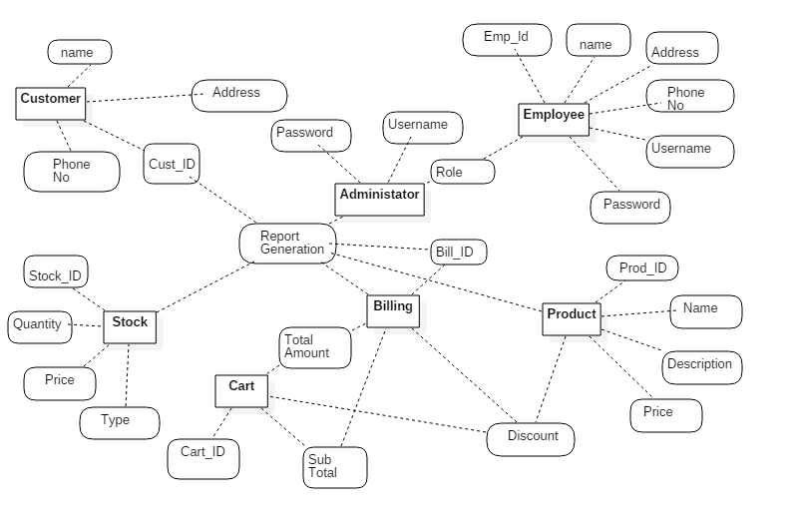

**Use Case Diagram:**

A **USE CASE DIAGRAM** at its simplest is a representation of a user's interaction with the system that shows the relationship between the user and the different [use cases](https://en.wikipedia.org/wiki/Use_case) in which the user is involved. A use case diagram can identify the different types of users of a system and the different use cases and will often be accompanied by other types of diagrams as well.

**User: ADMIN**

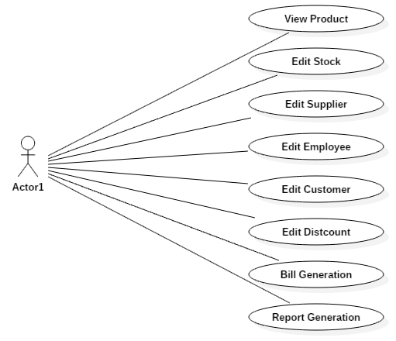

**User: Employee**

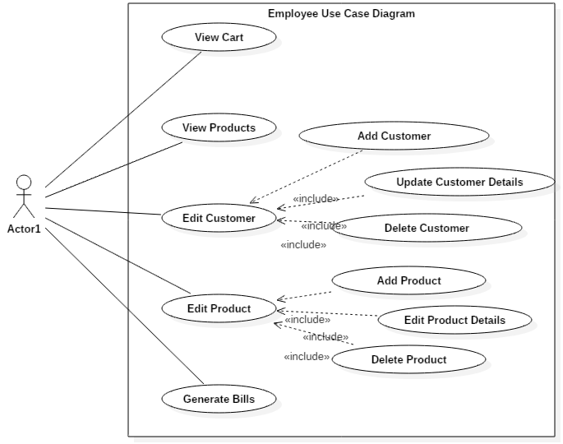

**User: Customer**

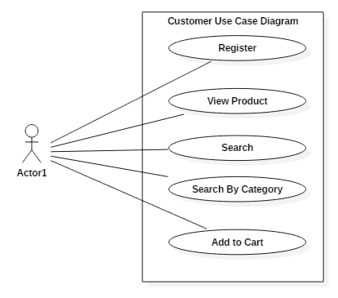

**Sequence Diagram:**

Sequence diagrams model the flow of logic within your system in a visual manner, enabling you both to document and validate your logic, and are commonly used for both analysis and design purposes. Sequence diagrams are the most popular UML artifact for dynamic modelling, which focuses on identifying the behaviour within your system. Other dynamic modelling techniques include [activity diagramming](http://agilemodeling.com/artifacts/activityDiagram.htm), [communication diagramming](http://agilemodeling.com/artifacts/communicationDiagram.htm), [timing diagramming](http://agilemodeling.com/artifacts/timingDiagram.htm), and [interaction overview diagramming](http://agilemodeling.com/artifacts/interactionOverviewDiagram.htm). Sequence diagrams, along with [class diagrams](http://agilemodeling.com/artifacts/classDiagram.htm) and [physical data models](http://agiledata.org/essays/dataModeling101.html) are in my opinion the most important design-level models for modern business application development.

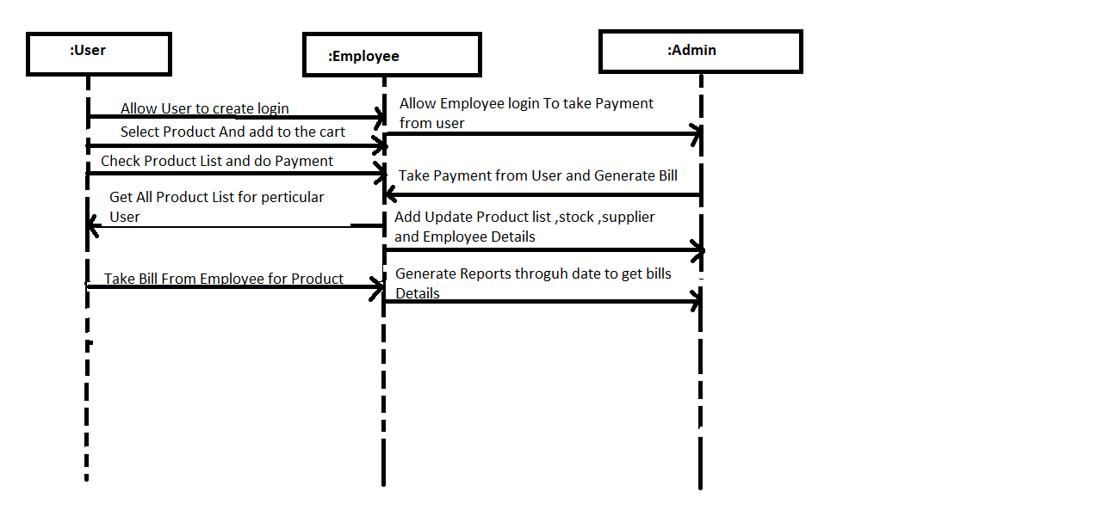

**Activity Diagram:**

Activity diagrams illustrate the dynamic nature of a system by modeling the flow of control from activity to activity. An activity represents an operation on some class in the system that results in a change in the state of the system. Typically, activity diagrams are used to model workflow or business processes and internal operation.

**Logging In**

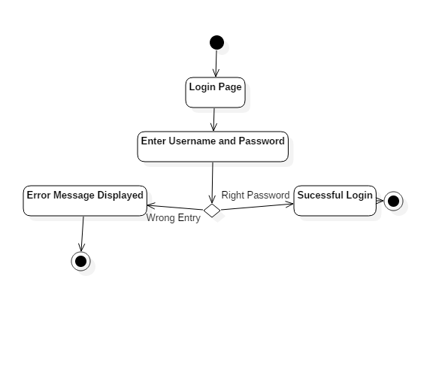

**Searching by Category**

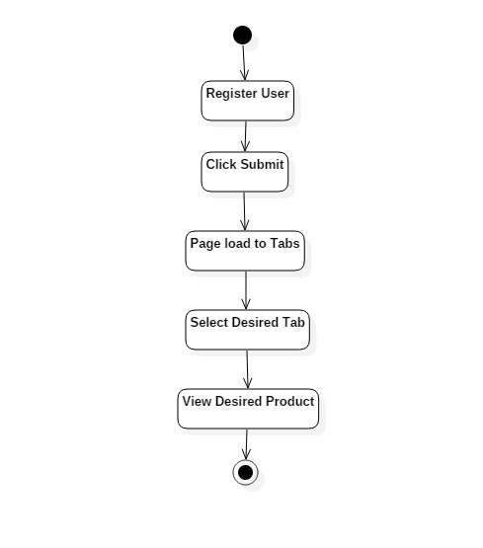

**Bill Generation**

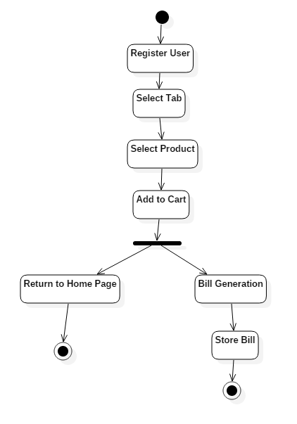

**GANTT CHART:**

A Gantt chart is a type of bar chart that illustrates a project Schedule. Gantt charts illustrate the start and finish dates of the terminal elements and summary elements of a project. Terminal elements and summary elements comprise the work breakdown structure of the project. A Gantt chart is good for monitoring the progress of the project as it moves along. Each row contains single task identification which usually consists of task name and task number.

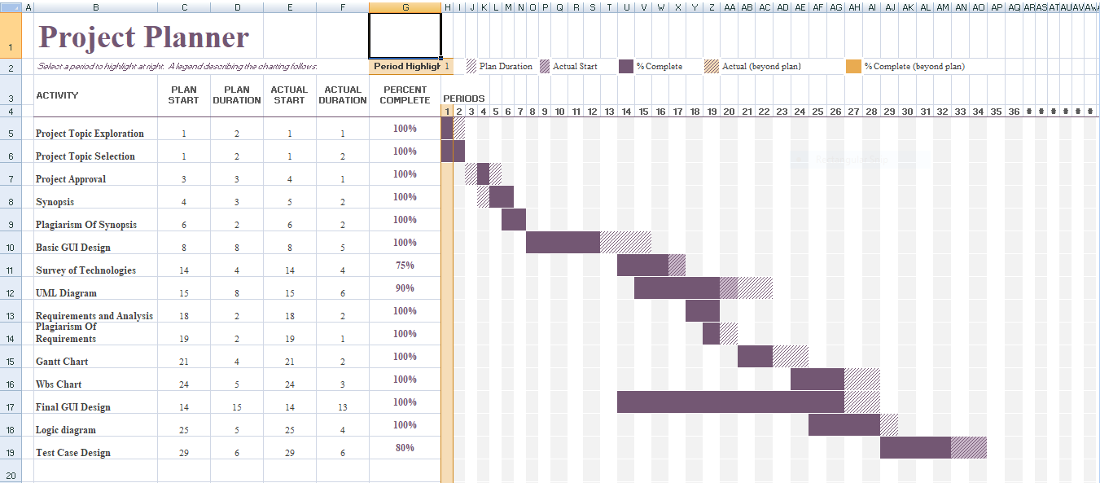

**SYSTEM IMPLEMENTATION**

* **Bill.cs**

using System;

using System.Collections.Generic;

using System.ComponentModel;

using System.Data;

using System.Drawing;

using System.Linq;

using System.Text;

using System.Windows.Forms;

using System.Data.SqlClient;

namespace Grocery_Management_Shop

{

public partial class Bill : Form

{

SqlConnection con = new SqlConnection(@"Data Source=ADITYA-123\SQLSERVER;Initial Catalog=Grocery_Management_Shop;Integrated Security=True");

SqlCommand cmd = new SqlCommand();

SqlDataReader dr;

DataTable dt=new DataTable();

public Bill()

{

InitializeComponent();

}

private void btnShowRecord_Click(object sender, EventArgs e)

{

string dateTime = dateTimePicker1.Text;

con.Open();

cmd = new SqlCommand("select CS.Cname,CS.Address, Cart_ID,PD.Name,PD.Prize,Quantity,subTotal from Carts CA " +

"inner join Product PD on PD.Product_ID=CA.Product_Id inner join Cutsomer CS on CS.Cust_ID=CA.CustID", con);

dr = cmd.ExecuteReader();

dt.Load(dr);

dataGridView1.DataSource = dt;

con.Close();

}

}

}

* **Cart.cs**

using System;

using System.Collections.Generic;

using System.ComponentModel;

using System.Data;

using System.Drawing;

using System.Linq;

using System.Text;

using System.Windows.Forms;

using System.Data.SqlClient;

namespace Grocery_Management_Shop

{

public partial class Cart : Form

{

SqlConnection con = new SqlConnection(@"Data Source=ADITYA-123\SQLSERVER;Initial Catalog=Grocery_Management_Shop;Integrated Security=True");

SqlCommand cmd, cmd1;

SqlDataReader dr;

DataTable dt;

int CustId;

public Cart()

{

InitializeComponent();

}

private void Cart_Load(object sender, EventArgs e)

{

dt = new DataTable();

con.Open();

cmd = new SqlCommand("select MAX(Cust_ID) from Cutsomer", con);

CustId = Convert.ToInt16(cmd.ExecuteScalar());

lblCustID.Text = CustId.ToString();

cmd1 = new SqlCommand("Select Product_Id,Product_Prize,Quantity,subTotal from Carts where CustID='" + CustId + "'", con);

dr = cmd1.ExecuteReader();

dt.Load(dr);

dataGridView1.DataSource = dt;

con.Close();

}

private void button1_Click(object sender, EventArgs e)

{

con.Open();

cmd = new SqlCommand("select sum(CAST((subTotal)as int)) from Carts where CustID='" + CustId + "'", con);

int TotalAmount = Convert.ToInt16(cmd.ExecuteScalar());

textBox1.Text = TotalAmount.ToString();

con.Close();

}

public void billingTable()

{

DateTime datetime=DateTime.Now;

datetime.ToString();

con.Open();

// cmd = new SqlCommand("insert into Billing values('"+cartID+"','"+CustId+"','"+Subtotal+"','"+Total+"','"+datetime+"')");

con.Close();

}

}

}

* **Dairy_Bakery.cs**

using System;

using System.Collections.Generic;

using System.ComponentModel;

using System.Data;

using System.Drawing;

using System.Linq;

using System.Text;

using System.Windows.Forms;

using System.Data.SqlClient;

namespace Grocery_Management_Shop

{

public partial class Dairy_Bakery : Form

{

SqlConnection con = new SqlConnection(@"Data Source=ADITYA-123\SQLSERVER;Initial Catalog=Grocery_Management_Shop;Integrated Security=True");

SqlCommand cmd, cmd1;

SqlDataReader dr;

DataTable dt;

int CustId;

int stockId;

int SubTotal;

public Dairy_Bakery()

{

InitializeComponent();

}

private void Dairy_Bakery_Load(object sender, EventArgs e)

{

con.Open();

cmd = new SqlCommand("select MAX(Cust_ID) from Cutsomer", con);

CustId = Convert.ToInt16(cmd.ExecuteScalar());

lblCustID.Text = CustId.ToString();

con.Close();

con.Open();

cmd = new SqlCommand("select * from Product where Type='Dairy_Bakery'", con);

dr = cmd.ExecuteReader();

dt = new DataTable();

dt.Load(dr);

dataGridView1.DataSource = dt;

con.Close();

}

private void Cart_Click(object sender, EventArgs e)

{

Cart c = new Cart();

c.Show();

this.Hide();

}

private void btnDone_Click(object sender, EventArgs e)

{

con.Open();

cmd1 = new SqlCommand("insert into Carts (Product_Id,Product_Prize,Quantity,subTotal,CustID)values('" + stockId + "','" + txtPrize.Text + "','" + txtQuantity.Text + "','" + txtSubtotal.Text + "','" + CustId + "')", con);

int i = cmd1.ExecuteNonQuery();

if (i == 1)

{

MessageBox.Show("Added to the Cart");

txtQuantity.Text = "";

txtPID.Text = "";

txtPrize.Text = "";

txtSubtotal.Text = "";

}

con.Close();

}

private void button1_Click(object sender, EventArgs e)

{

stockId = Convert.ToInt16(txtPID.Text);

if (stockId != 0)

{

con.Open();

cmd = new SqlCommand("Select * from product where Product_ID='" + stockId + "'", con);

dr = cmd.ExecuteReader();

dt = new DataTable();

dt.Load(dr);

if (dt != null)

{

txtPrize.Text = dt.Rows[0]["Prize"].ToString();

}

con.Close();

}

else

{

MessageBox.Show("please select Stock ID");

}

}

private void txtQuantity_TextChanged(object sender, EventArgs e)

{

if (txtQuantity.Text != "")

{

SubTotal = Convert.ToInt32(txtQuantity.Text) * Convert.ToInt32(txtPrize.Text);

txtSubtotal.Text = Convert.ToString(SubTotal);

}

}

}

}

* **Eggs_Fish_Meat.cs**

using System;

using System.Collections.Generic;

using System.ComponentModel;

using System.Data;

using System.Drawing;

using System.Linq;

using System.Text;

using System.Windows.Forms;

using System.Data.SqlClient;

namespace Grocery_Management_Shop

{

public partial class Eggs_Fish_Meat : Form

{

SqlConnection con = new SqlConnection(@"Data Source=ADITYA-123\SQLSERVER;Initial Catalog=Grocery_Management_Shop;Integrated Security=True");

SqlCommand cmd, cmd1;

SqlDataReader dr;

DataTable dt;

int CustId;

int stockId;

int SubTotal;

public Eggs_Fish_Meat()

{

InitializeComponent();

}

private void Eggs_Fish_Meat_Load(object sender, EventArgs e)

{

con.Open();

cmd = new SqlCommand("select MAX(Cust_ID) from Cutsomer", con);

CustId = Convert.ToInt16(cmd.ExecuteScalar());

lblCustID.Text = CustId.ToString();

con.Close();

con.Open();

cmd = new SqlCommand("select * from Product where Type='Eggs_Fish_Meat'", con);

dr = cmd.ExecuteReader();

dt = new DataTable();

dt.Load(dr);

dataGridView1.DataSource = dt;

con.Close();

}

private void Cart_Click(object sender, EventArgs e)

{

Cart c = new Cart();

c.Show();

this.Hide();

}

private void button1_Click(object sender, EventArgs e)

{

stockId = Convert.ToInt16(txtPID.Text);

if (stockId != 0)

{

con.Open();

cmd = new SqlCommand("Select * from product where Product_ID='" + stockId + "'", con);

dr = cmd.ExecuteReader();

dt = new DataTable();

dt.Load(dr);

if (dt != null)

{

txtPrize.Text = dt.Rows[0]["Prize"].ToString();

}

con.Close();

}

else

{

MessageBox.Show("please select Stock ID");

}

}

private void btnDone_Click(object sender, EventArgs e)

{

con.Open();

cmd1 = new SqlCommand("insert into Carts (Product_Id,Product_Prize,Quantity,subTotal,CustID)values('" + stockId + "','" + txtPrize.Text + "','" + txtQuantity.Text + "','" + txtSubtotal.Text + "','" + CustId + "')", con);

int i = cmd1.ExecuteNonQuery();

if (i == 1)

{

MessageBox.Show("Added to the Cart");

txtQuantity.Text = "";

txtPID.Text = "";

txtPrize.Text = "";

txtSubtotal.Text = "";

}

con.Close();

}

private void txtQuantity_TextChanged(object sender, EventArgs e)

{

if (txtQuantity.Text != "")

{

SubTotal = Convert.ToInt32(txtQuantity.Text) * Convert.ToInt32(txtPrize.Text);

txtSubtotal.Text = Convert.ToString(SubTotal);

}

}

private void Cart_Click_1(object sender, EventArgs e)

{

Cart c = new Cart();

c.Show();

this.Hide();

}

}

}

* **Employee_form.cs**

using System;

using System.Collections.Generic;

using System.ComponentModel;

using System.Data;

using System.Drawing;

using System.Linq;

using System.Text;

using System.Windows.Forms;

using System.Data.SqlClient;

namespace Grocery_Management_Shop

{

public partial class Employee_form : Form

{

SqlConnection con = new SqlConnection(@"Data Source=ADITYA-123\SQLSERVER;Initial Catalog=Grocery_Management_Shop;Integrated Security=True");

SqlCommand cmd;

SqlDataReader dr;

DataTable dt;

public Employee_form()

{

InitializeComponent();

}

private void button1_Click(object sender, EventArgs e)

{

if (Txtname.Text != "" && txtadd.Text != "" && txtmob.Text != "" && txtpan.Text != "" && txtuser.Text != "" && txtpass.Text != "")

{

con.Open();

cmd = new SqlCommand("Insert into Employee values('" + Txtname.Text + "','" + txtadd.Text + "','" + txtmob.Text + "','" + txtpan.Text + "','" + txtuser.Text + "','" + txtpass.Text + "','" + cmbrole.Text + "')", con);

cmd.ExecuteNonQuery();

con.Close();

MessageBox.Show("User Created");

Refresh();

}

else

{

MessageBox.Show("Please Fill all the Employees Details");

}

}

public void Refresh()

{

SqlDataAdapter dataadapter = new SqlDataAdapter("select * from Employee", con);

DataSet ds = new DataSet();

con.Open();

dataadapter.Fill(ds, "Employee");

con.Close();

dataGridView1.DataSource = ds;

dataGridView1.DataMember = "Employee";

txtadd.Text = "";

txtmob.Text = "";

Txtname.Text = "";

txtpan.Text = "";

txtpass.Text = "";

txtuser.Text = "";

}

private void Employee_form_Load(object sender, EventArgs e)

{

con.Open();

cmd = new SqlCommand("select * from Employee", con);

dr = cmd.ExecuteReader();

dt = new DataTable();

dt.Load(dr);

dataGridView1.DataSource = dt;

con.Close();

}

private void btnSearch_Click(object sender, EventArgs e)

{

int EmpId = Convert.ToInt16(txtID.Text);

if (EmpId != null)

{

con.Open();

dt.Clear();

cmd = new SqlCommand("Select * from Employee where Emp_ID='" + EmpId + "'",con);

dr = cmd.ExecuteReader();

dt.Load(dr);

Txtname.Text = dt.Rows[0]["Name"].ToString();

txtadd.Text = dt.Rows[0]["Address"].ToString();

txtmob.Text = dt.Rows[0]["PanCardNo"].ToString();

txtpan.Text = dt.Rows[0]["PhoneNo"].ToString();

cmbrole.Text = dt.Rows[0]["Role"].ToString();

txtuser.Text = dt.Rows[0]["UserName"].ToString();

txtpass.Text = dt.Rows[0]["Password"].ToString();

con.Close();

}

else

{

MessageBox.Show("please select Employee ID");

}

}

private void BtnUpdate_Click(object sender, EventArgs e)

{

int EmpID = Convert.ToInt16(txtID.Text);

if (EmpID == 0)

{

MessageBox.Show("Please select Employee ID");

}

if (Txtname.Text != null && txtadd.Text != null && txtmob.Text != null && txtpass.Text != null && txtuser.Text != null && cmbrole.Text != null)

{

con.Open();

cmd = new SqlCommand("Update Employee set Name='" + Txtname.Text + "',Address='" + txtadd.Text + "',PanCardNo='" + txtpan.Text + "',PhoneNo='" + txtmob.Text + "',UserName='" + txtuser.Text + "',Password='" + txtpass.Text + "',Role='" + cmbrole.Text + "' where Emp_ID='" + EmpID + "'", con);

cmd.ExecuteNonQuery();

con.Close();

Refresh();

MessageBox.Show("Employee detail Updated");

}

else

{

MessageBox.Show("Please Fill all Details");

}

}

}

}

* **Employee_login.cs**

using System;

using System.Collections.Generic;

using System.ComponentModel;

using System.Data;

using System.Drawing;

using System.Linq;

using System.Text;

using System.Windows.Forms;

namespace Grocery_Management_Shop

{

public partial class Employee_login : Form

{

public Employee_login()

{

InitializeComponent();

}

private void button1_Click(object sender, EventArgs e)

{

Cart cart = new Cart();

cart.Show();

this.Hide();

}

}

}

* **Fruits_Vegetable.cs**

using System;

using System.Collections.Generic;

using System.ComponentModel;

using System.Data;

using System.Drawing;

using System.Linq;

using System.Text;

using System.Windows.Forms;

using System.Data.SqlClient;

namespace Grocery_Management_Shop

{

public partial class Fruits_Vegetables : Form

{

SqlConnection con = new SqlConnection(@"Data Source=ADITYA-123\SQLSERVER;Initial Catalog=Grocery_Management_Shop;Integrated Security=True");

SqlCommand cmd,cmd1;

SqlDataReader dr;

DataTable dt;

int CustId;

int stockId;

int SubTotal;

public Fruits_Vegetables()

{

InitializeComponent();

}

private void Fruits_Vegetables_Load(object sender, EventArgs e)

{

con.Open();

cmd = new SqlCommand("select MAX(Cust_ID) from Cutsomer",con);

CustId=Convert.ToInt16(cmd.ExecuteScalar());

lblCustID.Text = CustId.ToString();

con.Close();

con.Open();

cmd = new SqlCommand("select * from Product where Type='Fruits_Vegetables'",con);

dr= cmd.ExecuteReader();

dt = new DataTable();

dt.Load(dr);

dataGridView1.DataSource = dt;

con.Close();

}

private void Cart_Click(object sender, EventArgs e)

{

Cart c = new Cart();

c.Show();

this.Hide();

}

private void button1_Click_1(object sender, EventArgs e)

{

stockId = Convert.ToInt16(txtPID.Text);

if (stockId != 0)

{

con.Open();

cmd = new SqlCommand("Select * from product where Product_ID='" + stockId + "'", con);

dr = cmd.ExecuteReader();

dt = new DataTable();

dt.Load(dr);

if (dt != null)

{

txtPrize.Text = dt.Rows[0]["Prize"].ToString();

}

con.Close();

}

else

{

MessageBox.Show("please select Stock ID");

}

}

private void btnDone_Click(object sender, EventArgs e)

{

con.Open();

cmd1 = new SqlCommand("insert into Carts (Product_Id,Product_Prize,Quantity,subTotal,CustID)values('" + stockId + "','" + txtPrize.Text + "','" + txtQuantity.Text + "','" + txtSubtotal.Text + "','" + CustId + "')", con);

int i = cmd1.ExecuteNonQuery();

if (i == 1)

{

MessageBox.Show("Added to the Cart");

txtQuantity.Text = "";

txtPID.Text = "";

txtPrize.Text = "";

txtSubtotal.Text = "";

}

con.Close();

}

private void txtQuantity_TextChanged(object sender, EventArgs e)

{

if (txtQuantity.Text != "")

{

SubTotal = Convert.ToInt32(txtQuantity.Text) * Convert.ToInt32(txtPrize.Text);

txtSubtotal.Text = Convert.ToString(SubTotal);

}

}

}

}

* **Grains.cs**

using System;

using System.Collections.Generic;

using System.ComponentModel;

using System.Data;

using System.Drawing;

using System.Linq;

using System.Text;

using System.Windows.Forms;

using System.Data.SqlClient;

namespace Grocery_Management_Shop

{

public partial class Grains : Form

{

SqlConnection con = new SqlConnection(@"Data Source=ADITYA-123\SQLSERVER;Initial Catalog=Grocery_Management_Shop;Integrated Security=True");

SqlCommand cmd, cmd1;

SqlDataReader dr;

DataTable dt;

int CustId;

int stockId;

int SubTotal;

public Grains()

{

InitializeComponent();

}

private void Grains_Load(object sender, EventArgs e)

{

con.Open();

cmd = new SqlCommand("select MAX(Cust_ID) from Cutsomer", con);

CustId = Convert.ToInt16(cmd.ExecuteScalar());

lblCustID.Text = CustId.ToString();

con.Close();

con.Open();

cmd = new SqlCommand("select * from Product where Type='Granis'", con);

dr = cmd.ExecuteReader();

dt = new DataTable();

dt.Load(dr);

dataGridView1.DataSource = dt;

con.Close();

}

private void Cart_Click(object sender, EventArgs e)

{

Cart c = new Cart();

c.Show();

this.Hide();

}

private void button1_Click_1(object sender, EventArgs e)

{

stockId = Convert.ToInt16(txtPID.Text);

if (stockId != 0)

{

con.Open();

cmd = new SqlCommand("Select * from product where Product_ID='" + stockId + "'", con);

dr = cmd.ExecuteReader();

dt = new DataTable();

dt.Load(dr);

if (dt != null)

{

txtPrize.Text = dt.Rows[0]["Prize"].ToString();

}

con.Close();

}

else

{

MessageBox.Show("please select Stock ID");

}

}

private void btnDone_Click(object sender, EventArgs e)

{

con.Open();

cmd1 = new SqlCommand("insert into Carts (Product_Id,Product_Prize,Quantity,subTotal,CustID)values('" + stockId + "','" + txtPrize.Text + "','" + txtQuantity.Text + "','" + txtSubtotal.Text + "','" + CustId + "')", con);

int i = cmd1.ExecuteNonQuery();

if (i == 1)

{

MessageBox.Show("Added to the Cart");

txtQuantity.Text = "";

txtPID.Text = "";

txtPrize.Text = "";

txtSubtotal.Text = "";

}

con.Close();

}

private void txtQuantity_TextChanged(object sender, EventArgs e)

{

if (txtQuantity.Text != "")

{

SubTotal = Convert.ToInt32(txtQuantity.Text) * Convert.ToInt32(txtPrize.Text);

txtSubtotal.Text = Convert.ToString(SubTotal);

}

}

}

}

* **Main_forms.cs**

using System;

using System.Collections.Generic;

using System.ComponentModel;

using System.Data;

using System.Drawing;

using System.Linq;

using System.Text;

using System.Windows.Forms;

namespace Grocery_Management_Shop

{

public partial class Main_form : Form

{

public Main_form()

{

InitializeComponent();

}

private void deleteEmployeeToolStripMenuItem_Click(object sender, EventArgs e)

{

}

private void Main_form_Load(object sender, EventArgs e)

{

}

private void addEmployeeToolStripMenuItem_Click(object sender, EventArgs e)

{

Employee_form empForm = new Employee_form();

empForm.MdiParent = this;

empForm.Show();

}

private void addProductToolStripMenuItem_Click(object sender, EventArgs e)

{

}

private void updateEmployeeToolStripMenuItem_Click(object sender, EventArgs e)

{

}

private void billsToolStripMenuItem_Click(object sender, EventArgs e)

{

Bill b1 = new Bill();

b1.MdiParent = this;

b1.Show();

}

private void addSupplierToolStripMenuItem_Click(object sender, EventArgs e)

{

SupplierDetails sup = new SupplierDetails();

sup.MdiParent = this;

sup.Show();

}

private void addStockToolStripMenuItem_Click(object sender, EventArgs e)

{

StockDetails std = new StockDetails();

std.MdiParent = this;

std.Show();

}

}

}

* **Snack_Beverages.cs**

using System;

using System.Collections.Generic;

using System.ComponentModel;

using System.Data;

using System.Drawing;

using System.Linq;

using System.Text;

using System.Windows.Forms;

using System.Data.SqlClient;

namespace Grocery_Management_Shop

{

public partial class Snack_Beverages : Form

{

SqlConnection con = new SqlConnection(@"Data Source=ADITYA-123\SQLSERVER;Initial Catalog=Grocery_Management_Shop;Integrated Security=True");

SqlCommand cmd, cmd1;

SqlDataReader dr;

DataTable dt;

int CustId;

int stockId;

int SubTotal;

public Snack_Beverages()

{

InitializeComponent();

}

private void Snack_Beverages_Load(object sender, EventArgs e)

{

con.Open();

cmd = new SqlCommand("select MAX(Cust_ID) from Cutsomer", con);

CustId = Convert.ToInt16(cmd.ExecuteScalar());

lblCustID.Text = CustId.ToString();

con.Close();

con.Open();

cmd = new SqlCommand("select * from Product where Type='Snack_Beverages'", con);

dr = cmd.ExecuteReader();

dt = new DataTable();

dt.Load(dr);

dataGridView1.DataSource = dt;

con.Close();

}

private void Cart_Click(object sender, EventArgs e)

{

Cart c = new Cart();

c.Show();

this.Hide();

}

private void button1_Click_1(object sender, EventArgs e)

{

stockId = Convert.ToInt16(txtPID.Text);

if (stockId != 0)

{

con.Open();

cmd = new SqlCommand("Select * from product where Product_ID='" + stockId + "'", con);

dr = cmd.ExecuteReader();

dt = new DataTable();

dt.Load(dr);

if (dt != null)

{

txtPrize.Text = dt.Rows[0]["Prize"].ToString();

}

con.Close();

}

else

{

MessageBox.Show("please select Stock ID");

}

}

private void btnDone_Click(object sender, EventArgs e)

{

con.Open();

cmd1 = new SqlCommand("insert into Carts (Product_Id,Product_Prize,Quantity,subTotal,CustID)values('" + stockId + "','" + txtPrize.Text + "','" + txtQuantity.Text + "','" + txtSubtotal.Text + "','" + CustId + "')", con);

int i = cmd1.ExecuteNonQuery();

if (i == 1)

{

MessageBox.Show("Added to the Cart");

txtQuantity.Text = "";

txtPID.Text = "";

txtPrize.Text = "";

txtSubtotal.Text = "";

}

con.Close();

}

private void txtQuantity_TextChanged(object sender, EventArgs e)

{

if (txtQuantity.Text != "")

{

SubTotal = Convert.ToInt32(txtQuantity.Text) * Convert.ToInt32(txtPrize.Text);

txtSubtotal.Text = Convert.ToString(SubTotal);

}

}

}

}

* **Spices.cs**

using System;

using System.Collections.Generic;

using System.ComponentModel;

using System.Data;

using System.Drawing;

using System.Linq;

using System.Text;

using System.Windows.Forms;

using System.Data.SqlClient;

namespace Grocery_Management_Shop

{

public partial class Spices : Form

{

SqlConnection con = new SqlConnection(@"Data Source=ADITYA-123\SQLSERVER;Initial Catalog=Grocery_Management_Shop;Integrated Security=True");

SqlCommand cmd, cmd1;

SqlDataReader dr;

DataTable dt;

int CustId;

int stockId;

int SubTotal;

public Spices()

{

InitializeComponent();

}

private void Spices_Load(object sender, EventArgs e)

{

con.Open();

cmd = new SqlCommand("select MAX(Cust_ID) from Cutsomer", con);

CustId = Convert.ToInt16(cmd.ExecuteScalar());

lblCustID.Text = CustId.ToString();

con.Close();

con.Open();

cmd = new SqlCommand("select * from Product where Type='Spices'", con);

dr = cmd.ExecuteReader();

dt = new DataTable();

dt.Load(dr);

dataGridView1.DataSource = dt;

con.Close();

}

private void Cart_Click(object sender, EventArgs e)

{

Cart c = new Cart();

c.Show();

this.Hide();

}

private void button1_Click(object sender, EventArgs e)

{

stockId = Convert.ToInt16(txtPID.Text);

if (stockId != 0)

{

con.Open();

cmd = new SqlCommand("Select * from product where Product_ID='" + stockId + "'", con);

dr = cmd.ExecuteReader();

dt = new DataTable();

dt.Load(dr);

if (dt != null)

{

txtPrize.Text = dt.Rows[0]["Prize"].ToString();

}

con.Close();

}

else

{

MessageBox.Show("please select Stock ID");

}

}

private void btnDone_Click(object sender, EventArgs e)

{

con.Open();

cmd1 = new SqlCommand("insert into Carts (Product_Id,Product_Prize,Quantity,subTotal,CustID)values('" + stockId + "','" + txtPrize.Text + "','" + txtQuantity.Text + "','" + txtSubtotal.Text + "','" + CustId + "')", con);

int i = cmd1.ExecuteNonQuery();

if (i == 1)

{

MessageBox.Show("Added to the Cart");

txtQuantity.Text = "";

txtPID.Text = "";

txtPrize.Text = "";

txtSubtotal.Text = "";

}

con.Close();

}

private void txtQuantity_TextChanged(object sender, EventArgs e)

{

if (txtQuantity.Text != "")

{

SubTotal = Convert.ToInt32(txtQuantity.Text) * Convert.ToInt32(txtPrize.Text);

txtSubtotal.Text = Convert.ToString(SubTotal);

}

}

private void Cart_Click_1(object sender, EventArgs e)

{

Cart c = new Cart();

c.Show();

this.Hide();

}

}

}

* **StockDetails.cs**

using System;

using System.Collections.Generic;

using System.ComponentModel;

using System.Data;

using System.Drawing;

using System.Linq;

using System.Text;

using System.Windows.Forms;

using System.Data.SqlClient;

namespace Grocery_Management_Shop

{

public partial class StockDetails : Form

{

SqlConnection con = new SqlConnection(@"Data Source=ADITYA-123\SQLSERVER;Initial Catalog=Grocery_Management_Shop;Integrated Security=True");

SqlCommand cmd;

SqlDataReader dr;

DataTable dt = new DataTable();

public StockDetails()

{

InitializeComponent();

}

private void button4_Click(object sender, EventArgs e)

{

txtStockName.Text = "";

txtStockQuantity.Text = "";

txtPrice.Text = "";

int stockId = Convert.ToInt16(txtID.Text);

if (stockId != null)

{

dt.Clear();

con.Open();

cmd = new SqlCommand("Select * from Stock where Stock_ID='" + txtID.Text + "'", con);

dr = cmd.ExecuteReader();

dt.Load(dr);

dataGridView1.DataSource = dt;

if (dt != null)

{

txtStockName.Text = dt.Rows[0]["Name"].ToString();

txtStockQuantity.Text = dt.Rows[0]["Quantity"].ToString();

txtPrice.Text = dt.Rows[0]["Price"].ToString();

cmbType.Text = dt.Rows[0]["Type"].ToString();

}

con.Close();

}

else

{

MessageBox.Show("please select Stock ID");

}

}

private void btnAdd_Click(object sender, EventArgs e)

{

if (txtStockQuantity.Text != "" && txtStockName.Text != "" && txtPrice.Text != "")

{

con.Open();

cmd = new SqlCommand("Insert into Stock values('" + txtStockName.Text + "','" + txtStockQuantity.Text + "','" + txtPrice.Text + "','" + cmbType.Text + "')", con);

cmd.ExecuteNonQuery();

con.Close();

MessageBox.Show("Stock Added");

Refresh();

}

else

{

MessageBox.Show("Please Fill all Details");

}

}

private void btnUpdate_Click(object sender, EventArgs e)

{

int StockID = Convert.ToInt16(txtID.Text);

if (txtID.Text == null)

{

MessageBox.Show("Please select Stock ID");

}

if (txtStockQuantity.Text != null && txtStockName.Text != null && txtPrice.Text != null)

{

con.Open();

cmd = new SqlCommand("Update Stock set Name='" + txtStockName.Text + "',Quantity='" + txtStockQuantity.Text + "',Price='" + txtPrice.Text + "',Type='" + cmbType.Text + "' where Stock_ID='" + StockID + "'", con);

cmd.ExecuteNonQuery();

con.Close();

MessageBox.Show("Stock Updated");

Refresh();

}

else

{

MessageBox.Show("Please Fill all Details");

}

}

public void Refresh()

{

SqlDataAdapter dataadapter = new SqlDataAdapter("select * from Stock", con);

DataSet ds = new DataSet();

con.Open();

dataadapter.Fill(ds, "Stock");

con.Close();

dataGridView1.DataSource = ds;

dataGridView1.DataMember = "Stock";

txtStockName.Text = "";

txtStockQuantity.Text = "";

txtPrice.Text = "";

}

private void StockDetails_Load(object sender, EventArgs e)

{

Refresh();

}

}

}

* **SupplierDetails.cs**

using System;

using System.Collections.Generic;

using System.ComponentModel;

using System.Data;

using System.Drawing;

using System.Linq;

using System.Text;

using System.Windows.Forms;

using System.Data.SqlClient;

namespace Grocery_Management_Shop

{

public partial class SupplierDetails : Form

{

SqlConnection con = new SqlConnection(@"Data Source=ADITYA-123\SQLSERVER;Initial Catalog=Grocery_Management_Shop;Integrated Security=True");

SqlCommand cmd;

SqlDataReader dr;

DataTable dt=new DataTable();

public SupplierDetails()

{

InitializeComponent();

}

private void btnSearch_Click(object sender, EventArgs e)

{

int SupplierId = Convert.ToInt16(txtID.Text);

if (txtID.Text != null)

{

dt.Clear();

con.Open();

cmd = new SqlCommand("Select * from Supplier where Sup_ID='" + txtID.Text + "'",con);

dr = cmd.ExecuteReader();

dt.Load(dr);

txtName.Text = dt.Rows[0]["Name"].ToString();

txtAddress.Text = dt.Rows[0]["Address"].ToString();

txtComName.Text = dt.Rows[0]["Company_name"].ToString();

txtprice.Text = dt.Rows[0]["prize"].ToString();

txtQuantity.Text = dt.Rows[0]["quentity"].ToString();

con.Close();

}

else

{

MessageBox.Show("please select Supplier ID");

}

}

private void btnAdd_Click(object sender, EventArgs e)

{

if (txtName.Text != "" && txtAddress.Text != "" && txtComName.Text != "")

{

con.Open();

cmd = new SqlCommand("Insert into Supplier values('" + txtName.Text + "','" + txtAddress.Text + "','" + txtComName.Text + "','" + txtprice.Text + "','" + txtQuantity.Text + "')", con);

cmd.ExecuteNonQuery();

con.Close();

MessageBox.Show("Stock Added");

Refresh();

}

else

{

MessageBox.Show("Please Fill all Details");

}

}

private void btnUpdate_Click(object sender, EventArgs e)

{

int SupplierID = Convert.ToInt16(txtID.Text);

if (txtID.Text == null)

{

MessageBox.Show("Please select Supplier ID");

}

if (txtName.Text != null && txtAddress.Text != null && txtprice.Text != null && txtComName.Text != null && txtQuantity.Text != null )

{

con.Open();

cmd = new SqlCommand("Update Supplier set Name='" + txtName.Text + "',Address='" + txtAddress.Text + "',Company_name='" + txtComName.Text + "',prize='" + txtprice.Text + "',quentity='" + txtQuantity.Text + "' where Sup_ID='" + SupplierID + "'", con);

cmd.ExecuteNonQuery();

con.Close();

MessageBox.Show("Stock Updated");

Refresh();

}

else

{

MessageBox.Show("Please Fill all Details");

}

}

public void Refresh()

{

SqlDataAdapter dataadapter = new SqlDataAdapter("select * from supplier", con);

DataSet ds = new DataSet();

con.Open();

dataadapter.Fill(ds, "supplier");

con.Close();

dataGridView1.DataSource = ds;

dataGridView1.DataMember = "supplier";

txtAddress.Text = "";

txtComName.Text = "";

txtName.Text = "";

txtprice.Text = "";

txtQuantity.Text = "";

}

private void SupplierDetails_Load(object sender, EventArgs e)

{

Refresh();

}

}

}

* **Tabs.cs**

using System;

using System.Collections.Generic;

using System.ComponentModel;

using System.Data;

using System.Drawing;

using System.Linq;

using System.Text;

using System.Windows.Forms;

using System.Data.SqlClient;

namespace Grocery_Management_Shop

{

public partial class Tabs : Form

{

SqlConnection con = new SqlConnection(@"Data Source=ADITYA-123\SQLSERVER;Initial Catalog=Grocery_Management_Shop;Integrated Security=True");

SqlCommand cmd;

public Tabs()

{

InitializeComponent();

}

private void button6_Click(object sender, EventArgs e)

{

}

private void button5_Click(object sender, EventArgs e)

{

}

private void Tabs_Load(object sender, EventArgs e)

{

con.Open();

cmd = new SqlCommand("select MAX(Cust_ID) from Cutsomer",con);

lbl_ID.Text =Convert.ToString( cmd.ExecuteScalar());

con.Close();

}

private void button4_Click(object sender, EventArgs e)

{

Dairy_Bakery d_b = new Dairy_Bakery();

d_b.Show();

}

private void f_b_Click(object sender, EventArgs e)

{

Fruits_Vegetables a1 = new Fruits_Vegetables();

a1.Show();

}

private void s_b_Click(object sender, EventArgs e)

{

Snack_Beverages sb = new Snack_Beverages();

sb.Show();

}

private void Non_veg_Click(object sender, EventArgs e)

{

Eggs_Fish_Meat efm = new Eggs_Fish_Meat();

efm.Show();

}

private void s_Click(object sender, EventArgs e)

{

Spices ss = new Spices();

ss.Show();

}

private void g_p_Click(object sender, EventArgs e)

{

Grains g = new Grains();

g.Show();

}

}

}

* **Update_emp.cs**

using System;

using System.Collections.Generic;

using System.ComponentModel;

using System.Data;

using System.Drawing;

using System.Linq;

using System.Text;

using System.Windows.Forms;

using System.Data.SqlClient;

namespace Grocery_Management_Shop

{

public partial class Update_emp : Form

{

SqlConnection con = new SqlConnection(@"Data Source=ADITYA-123\SQLSERVER;Initial Catalog=Grocery_Management_Shop;Integrated Security=True");

SqlCommand cmd;

SqlDataReader dr;

public Update_emp()

{

InitializeComponent();

}

private void label7_Click(object sender, EventArgs e)

{

}

private void label1_Click(object sender, EventArgs e)

{

}

private void Emp_ID_TextChanged(object sender, EventArgs e)

{

}

private void btnSerach_Click(object sender, EventArgs e)

{

con.Open();

cmd = new SqlCommand("select * from Employee where Emp_ID ='"+Emp_ID.Text+"'",con);

dr= cmd.ExecuteReader();

while (dr.Read())

{

Txtname.Text = dr["Name"].ToString();

txtadd.Text = dr["Address"].ToString();

txtpan.Text = dr["PanCardNo"].ToString();

txtmob.Text = dr["PhoneNo"].ToString();

cmbrole.Text=dr["Role"].ToString();

}

con.Close();

}

}

}

* **Welcome_pg.cs**

using System;

using System.Collections.Generic;

using System.ComponentModel;

using System.Data;

using System.Drawing;

using System.Linq;

using System.Text;

using System.Windows.Forms;

using System.Data.SqlClient;

namespace Grocery_Management_Shop

{

public partial class Welcome_pg : Form

{

SqlConnection con = new SqlConnection(@"Data Source=ADITYA-123\SQLSERVER;Initial Catalog=Grocery_Management_Shop;Integrated Security=True");

SqlCommand cmd;

public int BillId;

public Welcome_pg()

{

InitializeComponent();

}

private void Adm_log_Click(object sender, EventArgs e)

{

Admin_login a1 = new Admin_login();

a1.Show();

this.Hide();

}

private void Cust_detail_Click(object sender, EventArgs e)

{

con.Open();

BillId = 0;

cmd = new SqlCommand("insert into Cutsomer values('"+Cus_name.Text+"','"+Cus_addr.Text+"','"+BillId+"')",con);

cmd.ExecuteNonQuery();

MessageBox.Show("Welcome User");

this.Hide();

Tabs Tb = new Tabs();

Tb.Show();

con.Close();

Tabs t1 = new Tabs();

t1.Show();

this.Hide();

}

private void Welcome_pg_Load(object sender, EventArgs e)

{

}

private void Addr_Click(object sender, EventArgs e)

{

}

private void Cus_addr_TextChanged(object sender, EventArgs e)

{

}

private void employeeLoginToolStripMenuItem_Click(object sender, EventArgs e)

{

Employee_login l = new Employee_login();

l.Show();

}

private void cartToolStripMenuItem_Click(object sender, EventArgs e)

{

Cart cc = new Cart();

cc.Show();

}

}

}

**RESULTS**

**Welcome Page:**

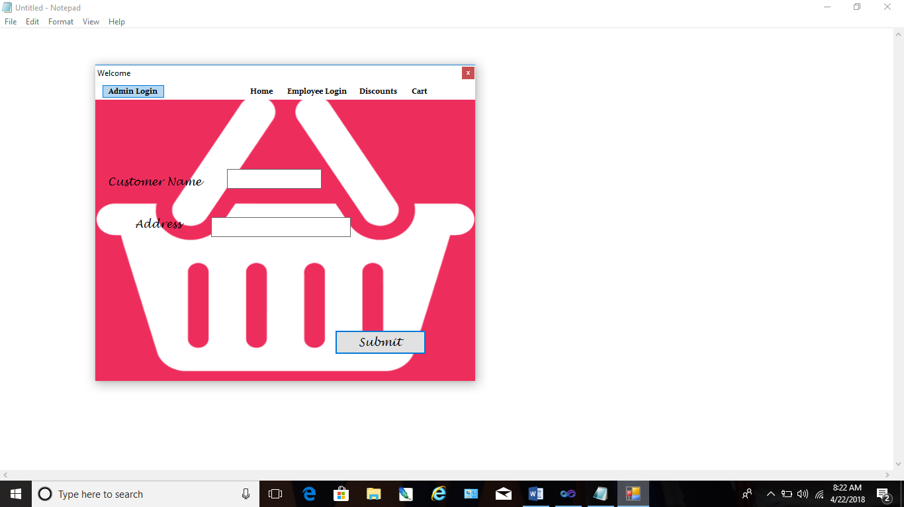

**Tabs Page:**

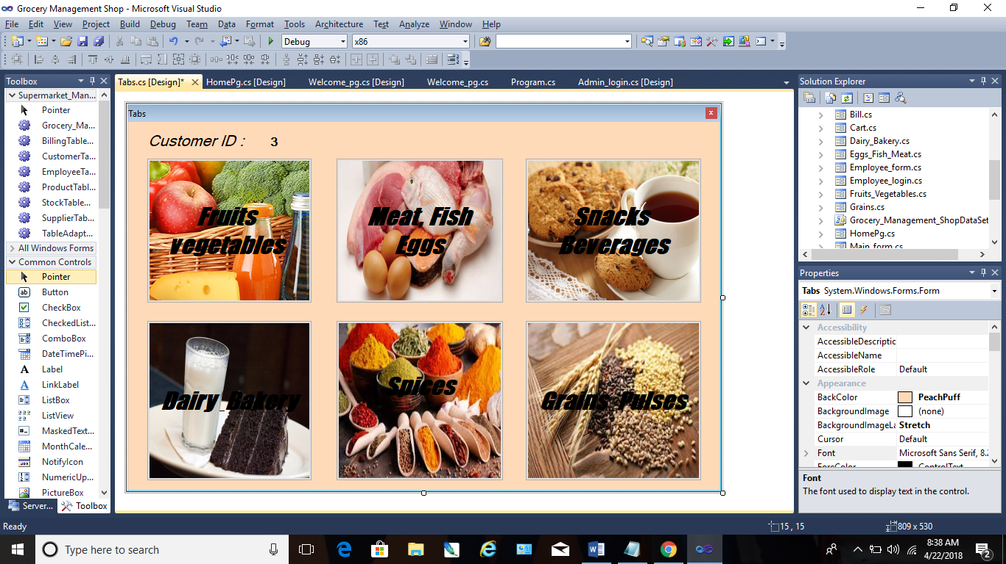

**Super Details Form :**

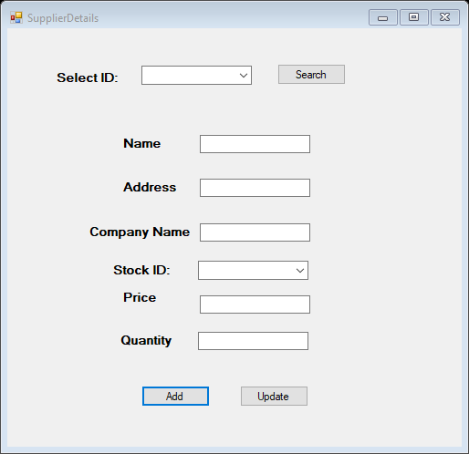

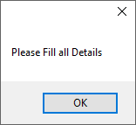

**Admin View (Employee Details Form):**

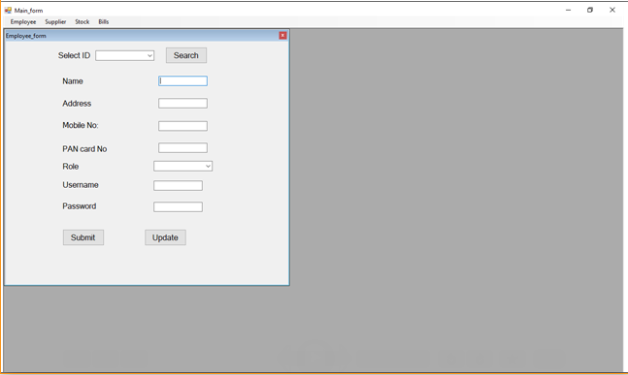

**Stock Details Form:**

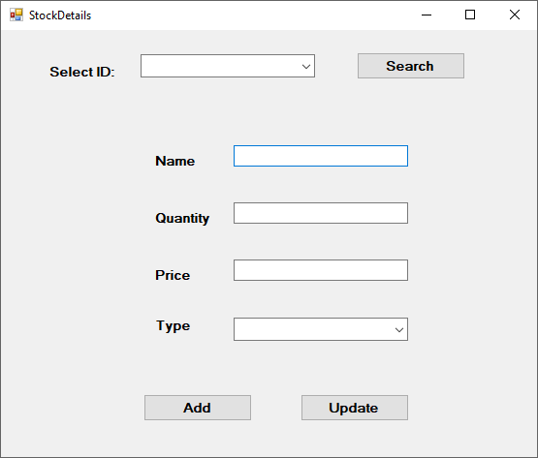

**Bill Generation (Report):**

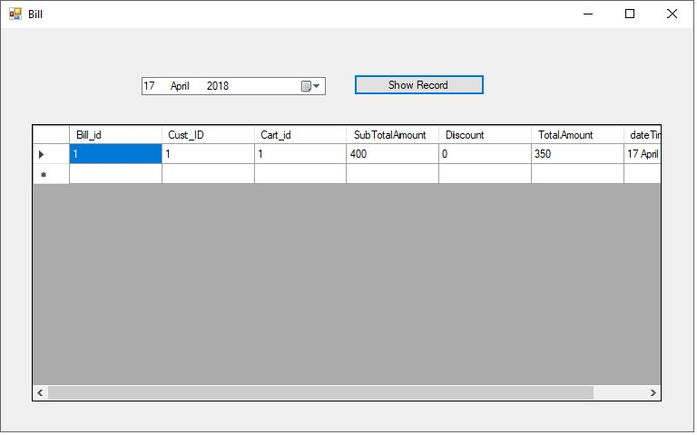

**CONCLUSION AND FUTURE**

**SCOPE**

**Future Scope:**

It can be summarized that the future scope of the project circle around maintaining information regarding:

* We can add printer in future.
* We can give more advance software in future for Supermarket Management system including more facilities.
* Integrated multiple load balancer to distribute the load of system.
* Create master and slave database structure to reduce the overload of the database queries.
* Implement the backup mechanism for taking backup of codebase a database on regular basis on difference server.

**Conclusion:**

* User must first Register/Login to avail the feature of Sales/Purchase
* After successful login and providing user information desired Windows shall be made available.
* Out of stock products shall not be displayed.
* If the Products are available then it can be added to the cart bythe user and it must be updated in the database concurrently.
* After that the Employee/Staff will generate a bill of the products added in the Cart.
* And the same will be updated to the database.
* The system displays the details of bill generated.
* The information is saved and the corresponding updating take place in the database***.***

**REFERENCES**

**Web References:**

➢[http://www.google.com](http://www.google.com/)

➢[http://www.codeproject.com](http://www.codeproject.com/)

➢[http://www.sourcecode.com](http://www.sourcecode.com/)

➢[www.wikipedia.com](http://www.wikipedia.com/)

**Bibliography**

➢SQLServer 2005byPaul Dubois.

➢SystemAnalysis&Design–Satzinger,Jackson,Burd,Cengage

Learning,India.

➢SoftwareEngineering-APractitioner’sApproach,McGrawHill

Int.

➢Integrated Approachto Software Engineering - PankajJalote

**PLAGIARISM**

**REPORT**

**Introduction**

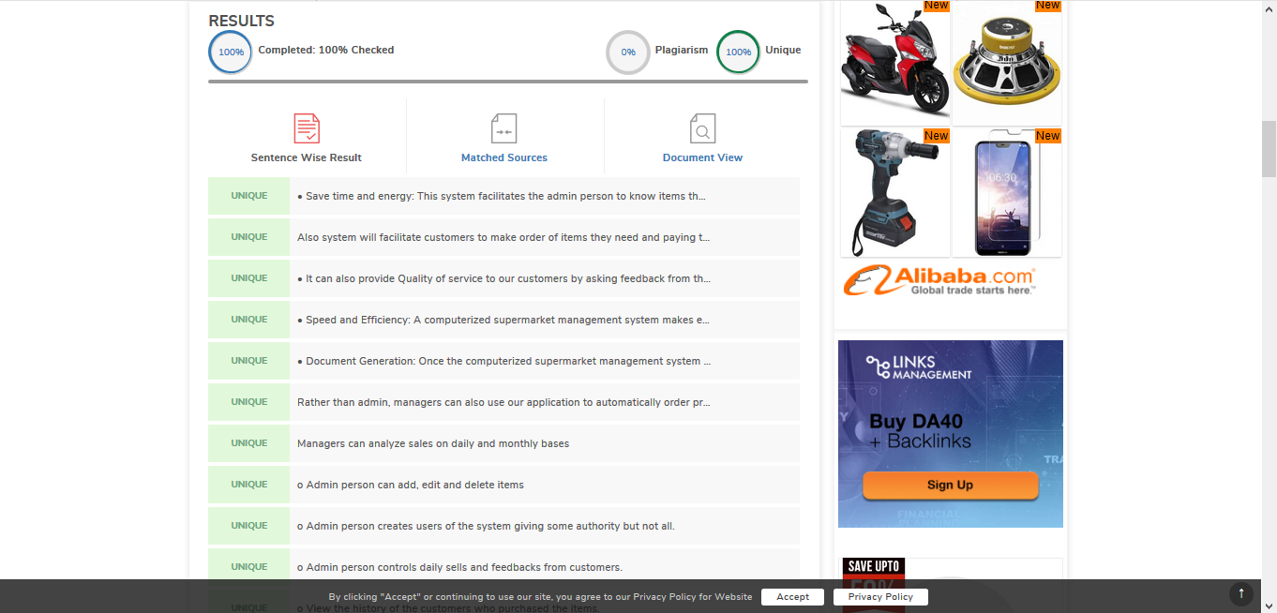

**Synopsis**

